Spirit of Life PCG
25235 Orange Street
PO Box 834
Los Molinos, CA 96055

PCG
August 5, 2022
We are pleased to provide a letter of reference for Drs. Steve and Deborah Powell. Steve and Deborah have been serving the Lord for more than 40 years. They have been attending our church for a few months now.
They have generous hearts and are compelled to further the Kingdom of God. They have a passion for the lost to know the Lord Jesus as their own personal savior, to be ushered into the Kingdom of God.
Steve and Deborah are surrogate parents to 36 orphans in Kitwe, Zambia housing. feeding and educating them each month. They have brought widows in to parent these orphans, encourage and train them to serve the Lord, in this way, they are providing a large loving family for the widows and orphans.
Dr. Deborah moves in the power and gifts of the Holy Spirit. She is an anointed speaker and singer. Dr. Steve is blessed with an administrative gift and the gift of helps. He and Deborah have been blessed to serve the Lord as evangelists, pastors, missionaries, and teachers.
Drs. Steve and Deborah truly love and serve the Lord Jesus.
Yours truly,
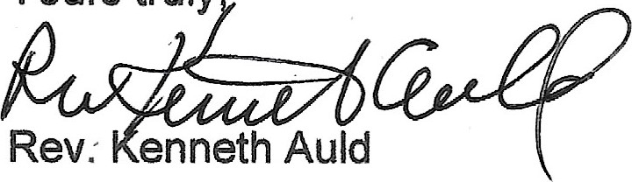
Pastor
Rev. Pamela Auld
Co-Pastor

To whom this may concern,

My name is Pastor Emanuel Galea, I am writing this letter of recommendation on behalf of Doctor of Divinity, Pastor Deborah Powell.

My twenty-five years plus of relationship with Pastor Deborah has been on a ministry and a close personal friendship basis as well. I would believe my view on Pastor Deborah can shed some clear incite on her character, not only as a minister of the gospel, but also in the prophetic nature of her ministry.

The many times she has ministered at our home church and other local churches with compassion and complete foresight, being clearly led by the spirit of God with complete accuracy in words of knowledge and the prophetic.

Her dedication to the ministry is something to be admired as well as her zeal for God is inspiring, which is palatable and causes those listening to yearn for the same experience with the Lord.

Concerning her being able to minister in the United States and abroad such as Zambia, speaks of her courage to go where God leads no matter what the challenge.

I would wholeheartedly trust & recommend Pastor Deborah Powell.

Sincerely, Rev E Galea

